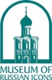
THE MUSEUM OF RUSSIAN ICONS
203 Union Street, Clinton, MA 01510 | www.museumofrussianicons.org
Nina Berger, Public Relations | ninajberger@gmail.com | 617.543.1595
Mary Delaney, Marketing Director | mdelaney@museumofrussianicons.org | 978.598.5000 x111

FOR IMMEDIATE RELEASE

After Sixteen Years of Leadership, Museum of Russian Icons Founding Director
Kent dur Russell to Retire in May, Leaving a Strong Legacy

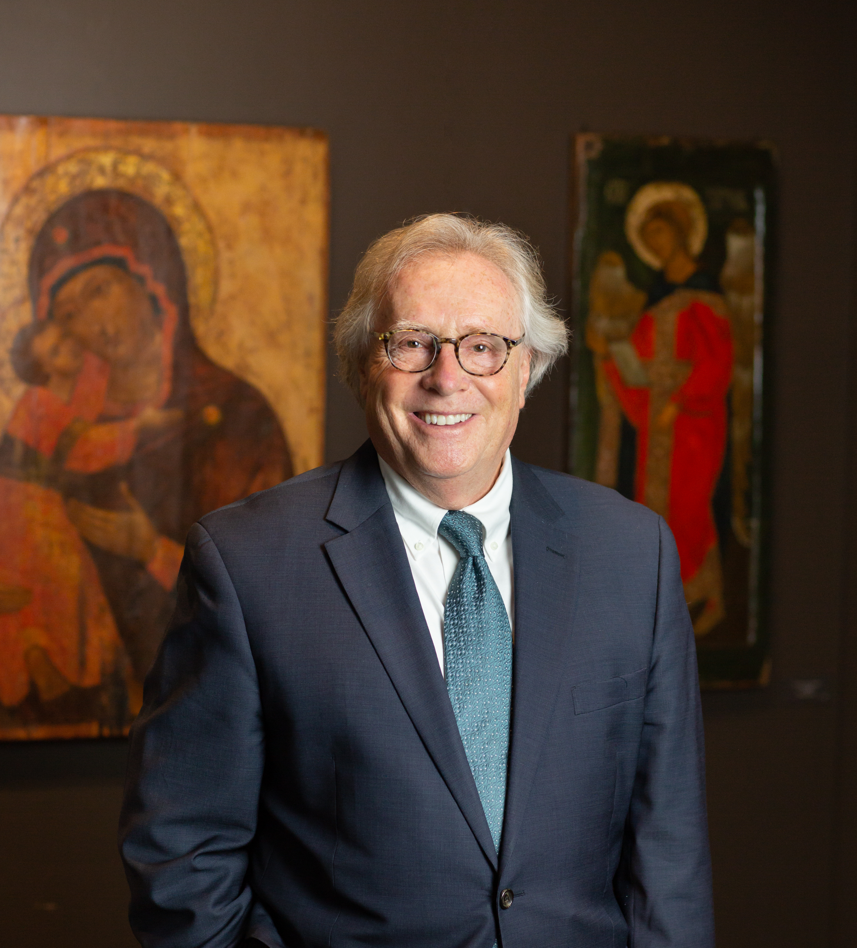

CLINTON, MA – Museum of Russian Icons Founding Director Kent dur Russell has announced that he plans to retire in May of 2022 after more than sixteen years of committed leadership at the Clinton-based museum. Founded in 2006, the Museum of Russian Icons is the only museum in the USA dedicated to Russian icons, holding the largest collection of icons outside of Russia. Russell was integral to the founding, building, and expansion of the Museum, and guided the institution through years of dynamic growth.

“Thanks to the vision of our founder Gordon Lankton and the exceptional efforts of our staff and supporters, our team created an American Alliance of Museums accredited organization in record time. Establishing this organization has been the capstone of my forty-five-year career in the museum field, which started in 1977 as a research fellow at the National Gallery of Ireland in Dublin,” said Russell. “I am very proud of our collective achievements and thankful to everyone whose creativity, vision, and hard work made them possible. The Museum is in great shape and ready for a seamless and smooth transition to new leadership.”

Before working with Lankton to open the Museum, Russell served as executive director of the Higgins Armory Museum in Worcester from 1996 to 2007. He was also the curator of collections at the Fitchburg Art Museum, the associate director for programs and education at the Parrish Art Museum in Southampton, N.Y., and managing director of the Arts Council of Northern Ireland Gallery in Belfast, Ireland.

“The Museum of Russian Icons has seen tremendous growth and development during Kent’s sixteen-year-long tenure,” says Jack McCabe, President of the Board of Trustees. “Kent's years of hard work, dedication, and dynamic leadership have helped make possible considerable achievements, earning the appreciation and gratitude of the local and museum communities. We are grateful for his commitment to ensuring that the Museum is positioned for continued organizational growth, financial stability, and limitless potential.”

THE STORY OF A PARTNERSHIP TO BUILD A NEW MUSEUM
“I met Gordon Lankton in 1995 while I was curator at the Fitchburg Art Museum,” recounts Russell. “I had heard that an art collector was running a manufacturing plant nearby in Clinton. So, I called him up, and he said, come on by, and I'll give you a tour. On that first visit, I was mesmerized by his plastic molding factory, Nypro. It was exciting to see raw plastic pellets enter one end of a high-tech molding machine and come out the other end as a Bic pen, or a precision-molded medical equipment component. After that, I kept in touch and asked him for his support for some projects, to which he always responded generously.

“Over time we became friends. I'd visit his house occasionally and look through his icon collection. Our growing friendship led to organizing his first museum show at the Higgins Armory Museum in 2004 called Shields of Faith. Gordon then asked me to join him and David Durrant in designing a museum for his icons, negotiating with the Board of the Higgins Armory one day off a week from my job as director there. I joined his team for two years while we designed and started to build the Museum in Clinton.

“Then, in 2006, when I was offered a leadership position at another museum in New England, I went to Gordon to say goodbye, and right then and there, he asked me to join his team full time instead. As the saying goes, he made me an offer I couldn't refuse! My work at his Museum has been a blast; working so closely with Gordon was challenging and exciting. It was also an exceptional opportunity for me to see philanthropy up close. The bonus was traveling with Gordon many times to Russia and Europe to organize international exhibitions for the Museum, hunt for icons, or attend auctions worldwide. Building the Museum was what Gordon loved to do; he dedicated his post-Nypro years to that project, so it was always fun and an adventure; it never felt like work. Isn't that just the best way to live a life?”

KENT DUR RUSSELL BIOGRAPHY
Born in New York City in 1952, where his father ran Russell Marketing Research, Kent dur Russell left the United States at an early age to attend boarding schools in France and Ireland. He attended Trinity College Dublin (TCD), where he received his B.A. in 1975 and an M.A. in 1978. He received a Graduate Certificate in the History of European Painting, was awarded the prestigious Purser-Griffith research fellowship at the National Gallery of Ireland, and holds a graduate degree in art history from City College, New York, where his research focused on Mark Rothko. Prior to his fellowship at the National Gallery, he embarked on a 7,500-mile journey by land from Dublin to Kathmandu through Europe, Iran, Afghanistan, Pakistan, India, and Nepal.

Russell has worked in curatorial roles at the National Gallery of Ireland, the Municipal Gallery of Modern Art in Dublin, Ireland, the Newry Art Center, Arts Council of Northern Ireland's Contemporary Art Gallery in Belfast, Northern Ireland, the Museum of Art, Science and Industry in Bridgeport, CT, the New Museum, the Studio Museum of Harlem, and the New Museum of Hispanic Art in New York City, the Parrish Art Museum in Southampton, NY, and the Fitchburg Art Museum, MA. He is a founding member of the Art Critics Association International (Ireland, 1977), art critic for Phoenix Magazine, Dublin, film critic at the BBC Northern Ireland, and arts commentator for numerous radio and television programs. Russell was a member of the Anglo-Irish Encounter (for peace in Northern Ireland), and served on the Northern Ireland Committee of the British School in Rome and the Advisory Council for the Belfast College of Art.

He has held adjunct and associate professor positions as an art historian at Quinnipiac College, CT, Fitchburg State College, MA, and Long Island University in Southampton, NY. Russell was on the editorial board of Arte en Columbia and has numerous publications and curated exhibitions to his name, including Artists from Northern Ireland at the Aeorta Gallery, Amsterdam, and Irish Artists from the Hendrix Gallery in NYC. He received the New York Cultural Council annual award for his exhibition The 1980s: A Look at America, and his exhibitions have been reviewed by The New York Times, The Times of London, The Burlington Magazine, and local press.

Russell is a trustee of the Lankton Charitable Corporation and the Ballets Russes Arts Initiative in Boston, and is the Vice President on the Executive Committee of Tower Hill Botanic Garden, MA. He is a corporator at the Worcester Art Museum and the Greater Worcester Community Foundation and has been on the Client Advisory Council of the U.S. Trust, Bank of America. Russell served as president of the New England Museum Association (NEMA) from 2005 to 2007, chaired the American Association of Museum (AAM)’s Council of Regional Associations, and has been an AAM member since 1976. He was the founding chairman of the Worcester Cultural Coalition, during which time he received the keys to the City of Worcester.

Russell’s partipation in civic, social, and cultural organizations include the Irish Georgian Society, the Tavern Club Boston, the Society of Mayflower Descendants (MA and NY), the Worcester Fire Society, the St. Wulstan Society, and the Worcester Club. He has been listed in Who's Who in the World since 2015. In 1988 he published A Little American Cookbook (Appletree Press), which ran into six printings; he also wrote as the anonymous social gossip columnist for Image Magazine during the 1980s. He lives with his Irish wife, a physician trained at Trinity College, Dublin, in the oldest house in Lunenburg (1723) and has two grown sons.

ABOUT THE MUSEUM
The Museum of Russian Icons preserves and exhibits one of the world’s largest collections of Orthodox Christian icons, bronze crosses, and Russian folk arts. Spanning over six centuries, the collection showcases the development of the Russian icon from its Egyptian and Byzantine roots and explores the spread of Orthodoxy across cultures. The Museum serves as a leading center for research and scholarship through the Center for Icon Studies and other institutional collaborations.

MUSEUM HOURS
Thursday, Friday, Saturday, and Sunday, 10am-4pm. Closed Monday–Wednesday.
Admission: Adults $12, seniors (59+) $10, Students $5, Children (13-17) $5, Children under 13 Free.

Follow the Museum of Russian Icons on Facebook, Twitter, Instagram, and YouTube.

Visit the website, www.museumofrussianicons.org, home of the online collection (including research papers on individual icons), a virtual tour of the Museum, the Journal of Icon Studies, and the British Museum’s catalogue of Byzantine and Greek icons.

